name : alveena naz
Reg no. fa25-bse-010
pf lab activity 7

Activity 1:
//import java.util.Scanner;
public class FirstJava
{
public static void main(String[] args)
{
//Scanner input = new Scanner(System.in);
int i = 5;
int j = 2;
int k = max(i,j);
System.out.println(" The maximum number is " + k);

}
static int max(int num1, int num2)
{
int result;
if(num1>num2)
result = num1;
else
result = num2;
return result;

}
}

Output:
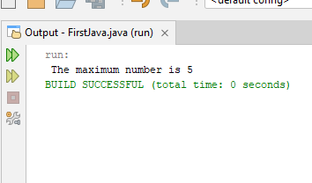

Activity 2:
//import java.util.Scanner;
public class FirstJava
{
public static void main(String[] args)
{
//Scanner input = new Scanner(System.in);
System.out.print(" The grade is ");
printGrade(78.5);
System.out.print(" The grade is ");
printGrade(59.5);

}
static void printGrade(double score)
{
if(score>=90)
System.out.println(" A");
else if(score>=80)
System.out.println(" B");
else if(score>=70)
System.out.println("C ");
else if(score>=60)
System.out.println(" D ");
else
System.out.println(" F ");

}
}

Output:
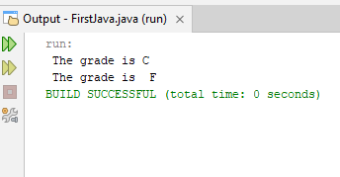

Activity 3:
//import java.util.Scanner;
public class FirstJava
{
public static void main(String[] args)
{
//Scanner input = new Scanner(System.in);
int num1 = 5;
int num2 = 9;
System.out.println(" Before swapping num1 is " + num1 + " and num2 is " + num2);
swap(num1,num2);

}
static void swap(int n1, int n2)
{
int temp;
temp = n2;
n2 = n1;
n1 = temp;
System.out.println(" \t After swapping the num1 is " + n1 + " and num2 is " + n2);

}
}

Output:
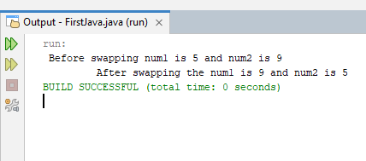

Activity 4:
//import java.util.Scanner;
public class FirstJava
{
public static void main(String[] args)
{
//Scanner input = new Scanner(System.in);
System.out.println(" The maximum number between 9 and 5 is " + max(9,5));
System.out.println(" The maximum number between 7.1 and 5.8 is " + max(7.1,5.8));
System.out.println(" The maximum number between 9.8 , 6.7 and 5.76 is " + max(9.8,6.7,5.67));

}
static int max(int n1, int n2)
{
int maximum = Math.max(n1,n2);
return maximum;

}
static double max(double num1, double num2)
{
double maximum = Math.max(num1,num2);
return maximum;
}
static double max(double num1, double num2, double num3)
{
double maximum ;
if(num1>num2)
{
if(num1>num3)
maximum = num1;
else
maximum = num3;
}
else
{
if(num2>num3)
maximum = num2;
else
maximum = num3;
}
return maximum;
}

}

Output:
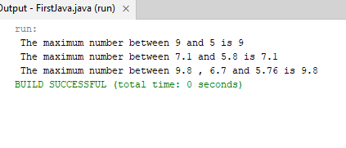

Activity 5:

import java.util.Scanner;
public class FirstJava
{
public static void main(String[] args)
{
Scanner input = new Scanner(System.in);
System.out.println(" enter an integer value ");
int n = input.nextInt();
System.out.println(" Factorial of " + n + " is " + fact(n));
}
static int fact(int n)
{
if(n==0)
return 1;
else
return n * fact(n-1);

}

}

OUTPUT:
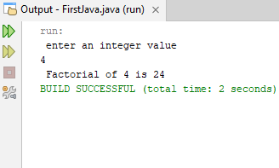

Activity 6:

import java.util.Scanner;
public class FirstJava
{
public static void main(String[] args)
{
Scanner input = new Scanner(System.in);
System.out.println(" enter an index ");
int index = input.nextInt();
for(int i = 0; i < index; i++)
{
System.out.print(fib(i) + " ");
}
}
static int fib(int n)
{
if(n==0)
return 0;
else if(n==1)
return 1;
else
return fib(n-1)+ (n-2);

}

}

OUTPUT:
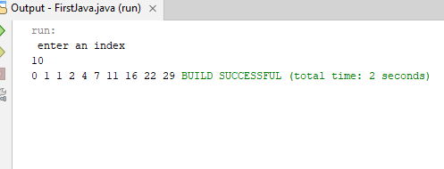

Graded task 1:

import java.util.Scanner;
public class FirstJava
{
public static void main(String[] args)
{
Scanner input = new Scanner(System.in);
System.out.println(" enter an integer");
int n = input.nextInt();
System.out.println(" The sum of digits are " + sumOfDigits(n));

}
static int sumOfDigits(int n)
{
if(n==0)
return 0;
else
return (n%10) + sumOfDigits(n/10);

}

}

Output:
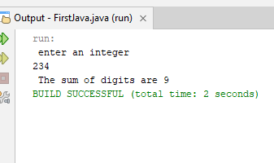

Graded task 2:

import java.util.Scanner;
public class FirstJava
{
public static void main(String[] args)
{
Scanner input = new Scanner(System.in);
System.out.println(" enter an integer");
int num = input.nextInt();
int reverse = 0;
System.out.println(reverseNum(num ,reverse));

}
static int reverseNum(int n , int reverse)
{
if(n==0)
{
return reverse;
}
else
{
int digit = n%10;
reverse = reverse * 10 + digit;
return reverseNum(n /10,reverse);
}
}

}

Output:
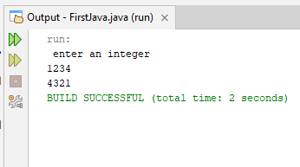

Graded task 2:

import java.util.Scanner;
public class FirstJava
{
public static void main(String[] args)
{
Scanner input = new Scanner(System.in);
System.out.println(" enter an integer");
int n = input.nextInt();
int reverse = 0;
int rev = reverseNum(n,reverse);
boolean palindrom =isPalindrom(n,rev);
if(palindrom)
System.out.println(" The number is palindrom ");
else
System.out.println(" the number is not a palindrom");

}
static int reverseNum(int n , int reverse)
{
if(n==0)
{
return reverse;
}
else
{
int digit = n%10;
reverse = reverse * 10 + digit;
return reverseNum(n /10,reverse);
}
}

static boolean isPalindrom(int n, int rev)
{
if(n==rev)
return true;
else
return false;
}
}

Output:

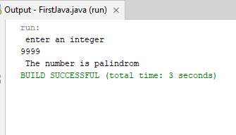

Graded task 3:

import java.util.Scanner;
public class FirstJava
{
public static void main(String[] args)
{
Scanner input = new Scanner(System.in);
System.out.println(" enter first number");
double num1 = input.nextDouble();
System.out.println(" enter second number");
double num2 = input.nextDouble();
System.out.println(" enter third number");
double num3 = input.nextDouble();
displaySortedNum(num1,num2,num3);

}
static void displaySortedNum(double num1, double num2,double num3)
{
double smallest = 0,middlest = 0, largest = 0;
if(num1<=num2 && num1<=num3)
{
smallest = num1;
if(num2<=num3)
{
middlest = num2;
largest = num3;
}
else
{
middlest = num3;
largest = num2;
}
}
else if(num2<=num3&& num2<=num1)
{
smallest = num2;
if(num3<=num1)
{
middlest = num3;
largest = num1;
}
else
{
middlest = num1;
largest = num3;
}
}
else
{
smallest = num3;
if(num1<=num2)
{
middlest = num1;
largest = num2;
}
else
{
middlest = num2;
largest = num1;
}

}
System.out.println(smallest+" "+middlest+" "+largest);
}

}

Output:
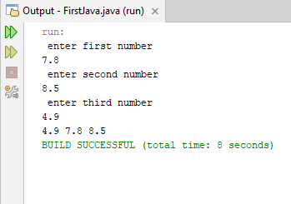

Graded task 4:

//import java.util.Scanner;
public class FirstJava
{
public static void main(String[] args)
{
//Scanner input = new Scanner(System.in);

for(int i =2000; i <=2020; i++)
{
int day = numOfDaysInYear(i);
System.out.println(" \t" + i + " " + day + " days");
}

}
static int numOfDaysInYear(int year)
{
int daysInYear = 0;
if((year%4==0 && year%100!=0) || year%400==0)
daysInYear = 366;
else
daysInYear = 365;
return daysInYear;
}

}

OUTPUT:
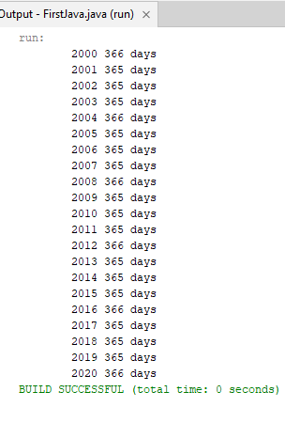

Graded task 5:
import java.util.Scanner;
public class FirstJava
{
public static void main(String[] args)
{
Scanner input = new Scanner(System.in);
String str = input.nextLine();
System.out.println(" The number of letters in " + str + " is " + countLetters(str));

}
static int countLetters(String str)
{
int count = 0;
for(int i = 0; i < str.length(); i++)
{
char ch = str.charAt(i);
boolean letter = Character.isLetter(ch);
if(letter)
count++;
}
return count;
}

}

Output:
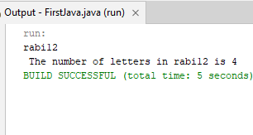

Graded task 6:
import java.util.Scanner;
public class FirstJava
{
public static void main(String[] args)
{
Scanner input = new Scanner(System.in);
System.out.println(" Enter a String line ");
String str = input.nextLine();
String result = "";
String word = "";
for(int i =0; i<str.length();i++)
{
char ch = str.charAt(i);
if(ch!=' ')
{
word+=ch;
}
else
{
result+= capitalize(word)+ " ";
word = "";
}

}
if(!word.isEmpty())
result+=capitalize(word)+ " ";
System.out.println(result);
}
static String capitalize(String word)
{
String remaining ="";
char first = word.charAt(0);
char upperCase = Character.toUpperCase(first);
for(int i =1;i<word.length();i++)
{
char c = word.charAt(i);
remaining+=c;
}
return upperCase+remaining;
}

}

OUTPUT;
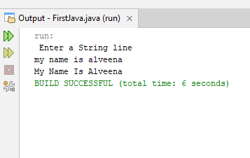

Question 7:
import java.util.Scanner;
public class FirstJava
{
public static void main(String[] args)
{
Scanner input = new Scanner(System.in);
System.out.println(" Enter a number ");
int n = input.nextInt();
printMatrix(n);

}
static void printMatrix(int n)
{
// rows
for(int i = 0; i <n; i++)
{
for(int k = 0; k <n; k++)
{
int random = (int)(Math.random()* 2);
System.out.print(random + " ");
}
System.out.println();
}
}

}

Output:
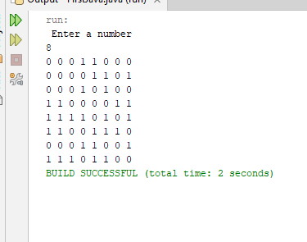

Question 8:
import java.util.Scanner;
public class FirstJava
{
public static void main(String[] args)
{
Scanner input = new Scanner(System.in);
System.out.println(" Enter a string ");
String str = input.nextLine();
countVowels(str);

}
static void countVowels(String str)
{
int count = 0;
for(int i = 0; i <str.length(); i++)
{
char letter = (str.charAt(i));
char ch = Character.toLowerCase(letter);
if(ch == 'a' || ch == 'e' ||ch == 'i' ||ch == 'o' ||ch == 'u')
count++;
}
System.out.println(count);
}

}

OUTPUT:
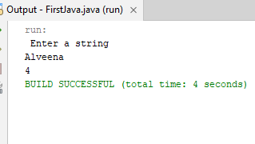

Question 10: part (a):
import java.util.Scanner;
public class FirstJava
{
public static void main(String[] args)
{
Scanner input = new Scanner(System.in);
System.out.println(" enter an integer");
int num = input.nextInt();
int reverse = 0;
System.out.println(reverseNum(num ,reverse));

}
static int reverseNum(int n , int reverse)
{
if(n==0)
{
return reverse;
}
else
{
int digit = n%10;
reverse = reverse * 10 + digit;
return reverseNum(n /10,reverse);
}

}

}

Output:
